Australian Human Rights Commission

Inquiry into the treatment of individuals suspected of people smuggling offences who say they are children

Submission by Tim J Cole PhD ScD FMedSci
Professor of Medical Statistics
MRC Centre of Epidemiology for Child Health, Institute of Child Health, University College London, UK
[Email]

Introduction
During the latter half of 2011 I was asked to give evidence in eight age assessment hearings in Australian courts, involving a total of 11 Indonesian fishermen charged with people smuggling who said they were under 18 years old when arrested. The cases came from Brisbane, Melbourne, Perth and Sydney. For each case I was asked to write an expert report giving my views on the statistical basis for the prosecution expert witness [name]’s evidence about bone age assessed using the Greulich-Pyle hand-wrist x-ray Atlas. In two of the cases I also gave oral evidence by videolink or telephone. Nine of the 11 cases were subsequently withdrawn by the prosecution. I was asked but declined to give evidence in two other cases, for reasons explained later.
The names of the 11 cases are as follows, in the order that their solicitors contacted me: [name, name & name, name & name & *name, name, *name, name, name and name]. All the cases except the two asterisked were subsequently withdrawn by the prosecution.
This submission is in four parts. It starts with the expert report that I wrote on [name]’s case, which is broadly similar to my other reports. [Name] used the Greulich-Pyle Atlas to claim that a male with a mature hand-wrist x-ray has only a 22% chance of being under 18. My report shows that this is wrong, and that a more appropriate figure is a 61% chance of their x-ray having been mature before age 18. The difference was due to [name] claiming age 19 as the mean age for a mature x-ray, whereas I argue that what matters is the age of attainment of the mature x-ray, which occurs earlier at 17.6 years.
Secondly, I extend the statistical argument to consider how informative bone age is for judging whether an individual is under 18. It turns out that the amount of information it contains depends on the age claimed by the individual (as opposed to their simply being under 18). In some circumstances bone age is informative but usually it is not. The issue here is the size of the standard deviation (SD) of the difference between bone age and chronological age, which is 15 months or more. So the confidence interval around the chronological age estimated from bone age is ±30 months (i.e. ±2 SDs), a range of 5 years. This lack of precision impacts on the value of bone age as evidence, and renders it uninformative except in extreme cases.
Thirdly, I show how these arguments extend to the use of dental age based on third molars (wisdom teeth), and that in general dental age is as uninformative as bone age for estimating chronological age.

1. Expert Report in the case of [accused]

EXPERT CERTIFICATE
In the matter of: CDPP v [accused]

Name: Professor Tim COLE
Work Address: MRC Centre of Epidemiology for Child Health, UCL Institute of Child Health, University College London, 30 Guilford Street, London WC1N 1EH, UK
Work Telephone: [Phone]
Occupation: Professor of medical statistics
STATES:
- This statement made by me accurately sets out the evidence that I would be prepared, if necessary, to give in court as a witness. This statement is true to the best of my knowledge and belief and I make it knowing that, if it is tendered in evidence, I will be liable to prosecution if I have wilfully stated in it anything that I know to be false, or do not believe to be true.

- I acknowledge that I have read the Expert Witness Code 44A; Victoria and I agree to be bound by the Code.

- I was supplied with the following documentation to assist with my report:
- Report of [name], dated 14 December 2010
- Report of [name], dated 27 April 2011
- Expert report of [name], dated 27 April 2011
- Expert report of [name], dated 3 August 2011
- Transcript of evidence of [name]. Dated 31 August 2011
- I am 64 years of age [date of birth].

- I hereby certify that I am a professor of medical statistics. I have a specialised knowledge based on the following training, study and experience as a medical statistician for the past 40 years. I hold the following qualifications:
- MA BPhil PhD ScD FMedSci

- In addition to my expertise as a medical statistician, I also have considerable knowledge and experience in the application of statistics to human growth and development, which has been my main research focus for the past 30 years. As evidence of this I attach a list of my 381 peer-reviewed research papers since 1970, of which the great majority relate to aspects of growth. In addition, in 2006 the British Royal College of Paediatrics and Child Health bestowed on me the title of Honorary Fellow, for services to growth assessment in paediatrics.

- I have been engaged by [name] of Victorian Legal Aid to prepare a report based on my expert opinion of:
- The intended purpose of the Greulich-Pyle Atlas
- The concept of skeletal age during childhood
- Using the GP Atlas to assess skeletal age
- Using the GP Atlas to assess chronological age
- What the GP Atlas standard for age 19 reflects
- Age of attainment of skeletal maturity based on the GP Atlas
- Age of attainment of skeletal maturity based on the TW3 manual
- Opinion on report of [name]
- Opinion on expert report of [name]
- [Name]’s choice of mean age 19 years and SD 15.4 months
- The statistical limitations of the Atlas
- Alternative probability of the subject, [accused], being under 18
- Opinion on report of [name]
- Conclusion
- My opinion follows:
- The intended purpose of the Greulich-Pyle Atlas
The Greulich-Pyle Radiographic Atlas ¹ was published in 1959 to help assess the skeletal age of children, based on the appearance of their hand-wrist x-ray. Skeletal age is one of a number of biological markers indicating how far along the road from birth to adult the child has travelled. By calibrating the distance travelled against chronological age it is possible to express skeletal maturity as an “age” in units of years, and on average a child’s skeletal “age” should match their chronological age.
- The concept of skeletal age during childhood
The process of bone growth takes place at the growth plates (or epiphyses) at the ends of the long bones. As the skeleton matures, the radiographic appearance of the growth plates changes in a well-defined way, so it is possible from reading the x-ray to judge, within a range of uncertainty, how far the child has travelled on their biological journey and what their skeletal “age” is. The journey ends when growth stops, at which point the child is adult. This is when all the growth plates have fused and no further growth is possible. The appearance of the x-ray is then adult, and remains so throughout life.
- Using the GP Atlas to assess skeletal age
The GP Atlas consists of a series of standard x-rays for specified skeletal ages, 31 standards from birth to 19 years for boys, and 27 from birth to 18 years for girls. Thus for example male standard 25 is for skeletal age 14 years. The reference sample was middle class US children from Cleveland Ohio in the 1930’s.
The assessor takes a child of known chronological age and compares their x-ray to the Atlas standards for the child’s sex and identifies the standard best matching the child’s x-ray. The skeletal age for that standard, or an intermediate age if part-way between two standards, then defines the child’s skeletal (or bone) age.
Greulich and Pyle explain their choice of standards for each age as follows (GP page 32):
“Each of the standards in this Atlas was selected from one hundred films of children of the same sex and age. The films of each of these series were arranged in the order of their relative skeletal status, from the least mature to the most mature. In most cases the film chosen as the standard is the one which, in our opinion, was most representative of the central tendency, or anatomical mode, of the particular array. The anatomical mode was frequently, but not always, at or near to the midpoint of the distribution of the one hundred films. It was farthest from the midpoint at those ages where, as a result of a major change in the rate of development, differences in the degree of skeletal development of the children resulted in a skewed distribution of the array.”
To précis, each standard is based on a group of 100 children of that chronological age, and the appearance of the standard x-ray corresponds to the typical, but not necessarily the mean, bone age in the group.
- Using the GP Atlas to assess chronological age
By definition, all children matched to a particular standard have the same bone age. However they do not all have the same chronological age, indeed their range of chronological ages is wide. This range can be expressed as a normal distribution and summarised by its mean and standard deviation (SD). The mean of the age distribution corresponds broadly to the nominal skeletal age for the standard (Greulich and Pyle’s procedure (above) ensures this), while the SD of skeletal ages for different chronological ages is documented in the Atlas in Tables III to VI.
This provides an alternative use of the information in the Atlas. If the mean and SD of the chronological age distribution are known, a given bone age can be converted to a probability that the subject is older or younger than a given chronological age.
However it is important to realise that the Atlas’s original purpose was to estimate bone age in growing children, not to decide what chronological age subjects with mature x-rays might be. Greulich and Pyle had no interest in such subjects, as they could not ascribe a bone age to them.
- What the GP Atlas standard for age 19 reflects
The Atlas records the spectrum of maturity seen in boys from birth to 19 years, and the age standard for 19 years documents the adult appearance of the x-ray. This is confirmed by the rubric accompanying the standard (and curiously there is nothing else in the Atlas about the age 19 standard being mature):
“The fusion of the radial epiphysis with its shaft completes the skeletal maturation of the hand and wrist.” (Boys, skeletal age 19 years, GP page 122)
It is important to be clear what this means: among 19-year-old males, most are skeletally mature. What it categorically does not mean is that males with an adult x-ray are on average 19 years old.
Note that Greulich and Pyle could have labelled this final standard “adult” rather than “age 19”, which would have been much clearer for age assessment purposes.
- Age of attainment of skeletal maturity based on the GP Atlas
Subjects with a mature x-ray have a skeletal age corresponding to that for all adults, so the upper limit of their likely chronological age is effectively unbounded, i.e. 100 years or more. However the lower limit of the range can be more precisely specified. It is clear that most 19-year-old males are skeletally mature (see above). This leads to the following questions: what proportion are mature at younger ages than 19, and what is the youngest age that adult x-rays are seen? These questions relate to the age of attainment of a subject’s mature x-ray, which is quite distinct from their current age. Since most x-rays are mature by age 19, the age of attainment must for most subjects be earlier than 19. But what is the distribution of this age of attainment?
Unsurprisingly the Atlas does not address the question directly, as it was irrelevant to Greulich and Pyle. However it does provide some indirect evidence, in its tables of the mean and SD of bone age for groups of children of known chronological age. The first (Table III, page 51) is for boys from the Brush Foundation Study, where a large number of children were each assessed once. These children were by definition skeletally immature, as Greulich and Pyle had to calculate their bone ages, which excluded those with mature x-rays. The oldest age group in the table is 17 years, where the mean bone age is 206.21 (SD 13.05) months. The second table (Table V, page 55) is for boys studied longitudinally by Dr Stuart at the Harvard School of Public Health. Here the oldest age in the table is again 17 years, where the mean bone age is 206 (SD 15.4) months.
There are two striking aspects to these tables. The first is that the oldest age group is 17 years. This shows that there were too few children with older bone ages to be included, i.e. that most children past 17 years had mature x-rays. The second point is the numbers of children in each year group, as shown here:
Age (years) | 12 | 13 | 14 | 15 | 16 | 17
Brush (n) | 165 | 175 | 163 | 124 | 99 | 68
Stuart (n) | 64 | 66 | 65 | 65 | 65 | 60
One would expect similar numbers in each group, but in the Brush Foundation Study the numbers fell off steeply after age 14, showing that children with immature x-rays aged 15 or more were progressively less common. In Stuart’s longitudinal study the numbers were fairly constant across age, but even here there were drop-outs at 17 years whose x-rays were clearly mature. Overall the table suggests that after 14 years there are increasing numbers of boys with mature x-rays, and after 17 years most are mature.
- Age of attainment of skeletal maturity based on the TW3 manual
To definitively answer the question “What is the distribution of the age of attainment of skeletal maturity” we must turn to a more recent publication, the TW3 bone age manual published in 2001,² which addresses the question directly. TW3 obtains bone age using a sophisticated bone scoring system that rates individual hand and wrist bones rather than the global appearance of the x-ray, and its database is larger (33,178 subjects) and more recent (1969-95) than for GP (TW3 pages 17-18).
The TW3 manual ² discusses the range of ages of bone maturation based on the RUS score, which summarises the 13 Radius, Ulna and Short (i.e. finger) bones. Table 8 (TW3 page 21) gives the 97th centile for age of attainment in boys as 15.1 years, meaning that 3% of boys have already reached skeletal maturity by this age. The corresponding 90th and 75th centiles are 15.8 and 16.7 years. So by 16.7 years a quarter of boys are skeletally mature. The Table does not include the 50th centile (i.e. median) age of attainment, but it can be estimated from the other centiles – see below.
- Opinion on report of [name] and [name]
[Name] and [name] use the Greulich-Pyle Atlas to estimate the bone age, and [name] purports to infer the likely chronological age, of the subject [accused]. He observes that the subject’s hand-wrist radiograph matches the Atlas radiograph of a 19-year-old (male standard 31, skeletal age 19 years, GP page 123). [Name] states that “In males, skeletal maturation at the hand is reached at approximately 19 years of age. … On average this is reached at 19 years”. He concludes, “it is a reasonable interpretation that [accused] is 19 years of age or older”.
The first statement is wrong for the reasons given above – the mean age for an adult x-ray is not 19 years. The second statement implies that the probability of [accused] being 19 years or older exceeds 50%. But without knowledge of the mean age or the variability around it this probability cannot be calculated. Thus on statistical grounds the opinion of name] is wrong and should be dismissed.
- Opinion on expert report of [name]
[Name] also provides an expert report with a statistical argument to justify the conclusions drawn in his report. He argues that subjects with an adult x-ray have a mean chronological age of 19 years with an SD of 15.4 months, which together make the probability of such subjects being under 18 years old only 22%. His calculation of the probability from the mean and SD is correct, but it depends on the mean and SD being appropriate, which they are not (see below). For this reason his calculation is flawed, his probability of 22% is wrong, and his opinion should be dismissed. A more appropriate probability is derived below.
- [Name]’s choice of mean age 19 years and SD 15.4 months
[Name]’s choice of mean age 19 years for a mature x-ray, based on the age 19 standard in the GP Atlas, has already been shown to be invalid. The SD of 15.4 months comes from Table V of the Atlas (GP page 55), as cited earlier for boys aged 17 with an immature x-ray. Thus [name]’s SD is inappropriate in two distinct ways: it is based on boys aged 17 not 19 years, with immature not mature x-rays. Thus to apply the SD of 15.4 months to a 19-year-old with a mature x-ray is entirely wrong.
- The statistical limitations of the Atlas
There are three important factors that affect the mean chronological ages attributed to the bone ages in the GP Atlas – the secular trend to earlier maturity (i.e. children maturing earlier now than they did in first half of the 20th century), ethnic differences in the rate of maturation, and socio-economic status.
The reference sample for the GP Atlas was privileged US children in the 1930s, with a relatively early age of maturation compared to other children at that time. Children born since then have tended to mature earlier, so they have “caught up” with the GP Atlas sample and the TW3 and GP bone ages are broadly similar.²
Differences between ethnic groups have been seen in the mean rate of skeletal maturation, but after allowing for the secular trend and for differences in socio-economic circumstances it is unclear how important the differences are.²
[Name]’s subsidiary report addresses these issues. He states “There has not been any professional recognition of a need to reassess the standards through fresh studies, because radiologists worldwide have not perceived any signiﬁcant clinical changes in the rate of skeletal development”. Yet the TW3 manual and its TW2 predecessor (published in 1975) both appeared long after the GP Atlas, which contradicts [name]’s assertion.
[Name] separately argues that ethnic differences in bone age are small and unimportant, a view which broadly agrees with the TW3 manual. Conversely he argues, quoting the review of Schmeling,³ that low socio-economic status and poor nutrition can affect bone age. This is certainly the conclusion of Schmeling’s review, but it is based on a series of papers many of them published over 40 years ago, some relating to malnourished children, and none from Indonesia. Furthermore the review does not quantify the likely effect on bone age of such factors, so it is impossible to know how to adjust for them.
- Alternative probability of the subject, [accused], being under 18
The distribution of the age of attainment of skeletal maturity can be estimated from the three centiles in Table 8 of TW3, reproduced here.
- Centile | 97th | 90th | 75th
- Age (years) | - 15.1 | 15.8 | 16.7
Assuming a normal distribution the mean is about 17.6 years and SD 16.5 months. From this the probability of attaining maturity before age 18 is about 61%, so it is more likely than not that [accused] was skeletally mature before this age.
- Opinion on report of [name]
I am in agreement with the views expressed by [name], particularly her comments on the ethics of using radiographic evidence for age determination. Also she highlights the fact that an x-ray matching the 19-year standard could equally come from a 40-year-old.
- Conclusion
[Accused] has a mature x-ray. The chance of his having become skeletally mature before age 18 is 61%. The conclusion by [name] that he is probably over 18 is statistically unsound, and arises from a fundamental misunderstanding of the GP Atlas and the nature of skeletal maturity.
This conclusion applies to [accused]. It also applies quite generally to other males whose chronological ages have been assessed as over 18 years based on a mature hand-wrist x-ray. A mature x-ray provides only weak evidence of a male being over 18.
References
- Greulich WW, Pyle SI. Radiographic atlas of skeletal development of the hand and wrist. 2nd ed. California: Stanford University Press; 1959.
- Tanner JM, Healy MJR, Goldstein H, Cameron N. Assessment of skeletal maturity and prediction of adult height (TW3 method). 3rd ed. London: WB Saunders; 2001.
- Schmeling A, Reisinger W, Loreck D, et al. Effects of ethnicity on skeletal maturation: consequences for forensic age estimations. International Journal of Legal Medicine 2000; 113: 253-258.

Signed:
T J Cole
18 October 2011

2. The evidential value of bone age
Bone age has in the past been used widely as evidence in forensic age assessment cases, though its use is controversial and some countries avoid it. This is partly because it involves exposing the individual to a small but ethically dubious dose of radiation. But there is also a feeling that the imprecision of bone age ought to rule it out as providing useful evidence. This is because developmental age in general, and bone age in particular, is only weakly linked to an individual’s chronological age. The age of puberty based on bone age has a standard deviation (SD) of over 15 months (see previous section). So the range of chronological ages seen in 95% of the population at this developmental stage extends over 5 years (±2 SDs), and two boys at this stage could be 5 years apart in chronological age. The same observation applies to other developmental markers such as age at peak height velocity or dental age.
So using developmental age to predict chronological age is an imprecise business. But it is important to be able to quantify this statement, in the sense of calculating the evidential value of bone age in a civil case where the individual claims to be under 18 yet has a mature x-ray. My report has shown that one can make a blanket statement about the chance of an individual with a mature x-ray being under 18, and the answer is 61%. But one can make a more nuanced statement about the value of this evidence, by expressing it in terms of a likelihood ratio. This it turns out depends on what the individual says about his chronological age –he may know it accurately or he may say only that he is under 18.
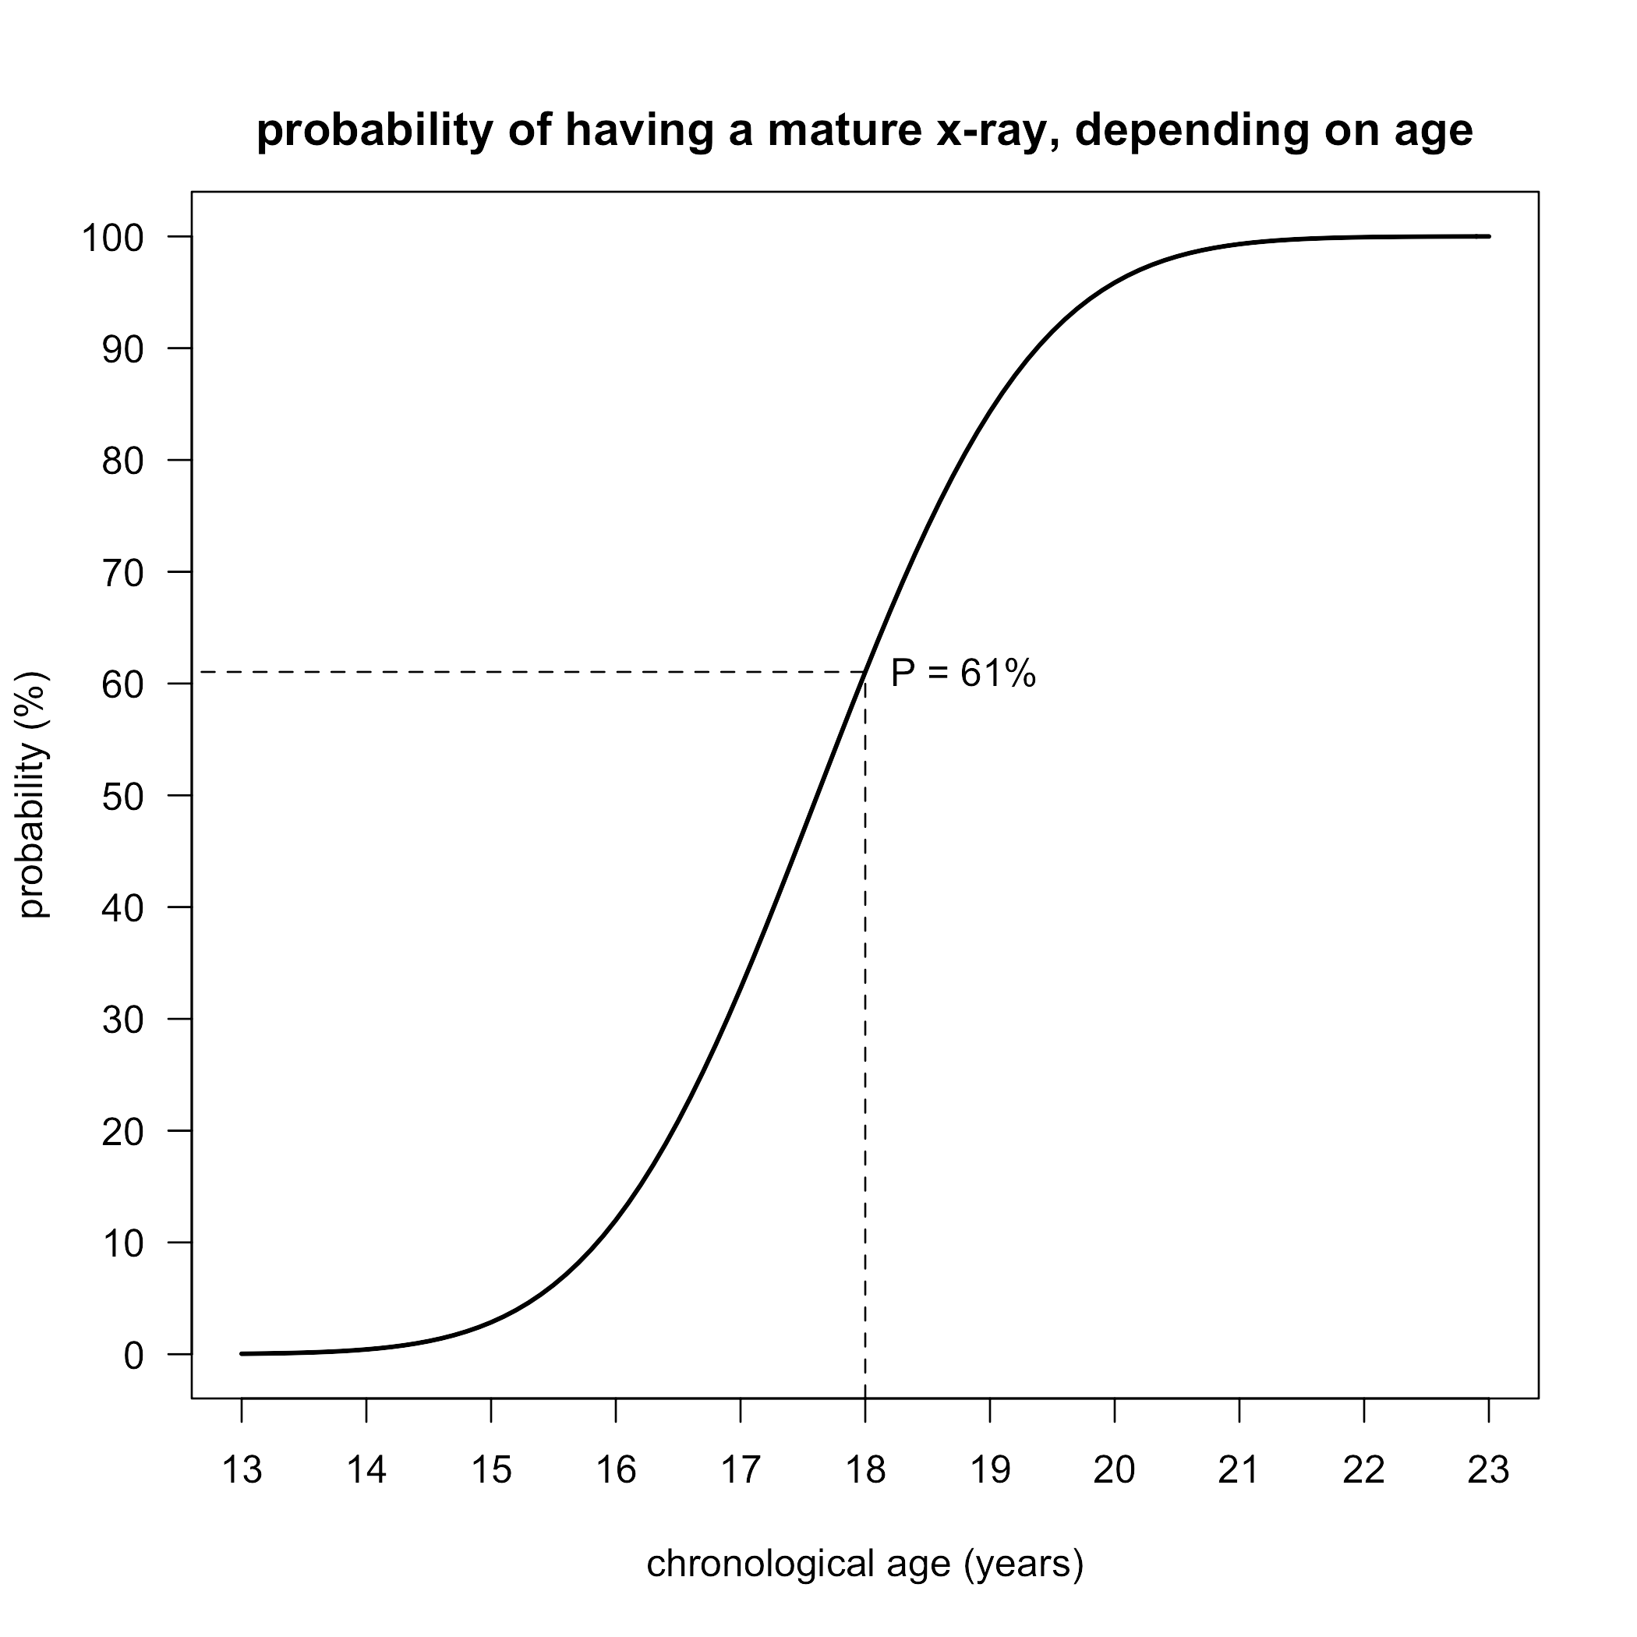
My expert report shows that the developmental marker to focus on is the age of attainment of the mature x-ray, which is normally distributed with a mean of 17.6 years and SD 16.5 months. Using this information one can plot the probability of having attained a mature x-ray at different ages. The figure below illustrates this, the cumulative frequency distribution, and it shows the 61% probability of an x-ray having matured before age 18, referred to earlier.
The shape of the graph is instructive. It shows that you are increasingly likely to have a mature x-ray the older you are. Before age 15 the chance is only about 3%, while after age 20 it is around 97%. There is a region where the x-ray is most unlikely to be mature (before age 14), a region where it is more or less likely (14 to 21), and a region where it almost inevitable (after age 21). The graph highlights how the probability changes in the central region, which is approximately four SDs wide.
One might think that the 61% probability of being mature before age 18 is what should interest the court. In a sense it is, but more generally the court wants to decide which of the two alternative scenarios – the individual being either over 18 or under 18 – is better supported by the evidence. For this the court needs to compare two different probabilities – that of being over 18 with a mature x-ray versus that of being under 18 with a mature x-ray. Ideally the probability should be close to 100% over 18 and close to 0% under 18, and the ratio of the two probabilities is a concise summary of the evidential value of the x-ray. This ratio is known as the likelihood ratio (LR), and the further it is from 1 then the more informative the x-ray is. The LR is an important component of Bayes’ Theorem (discussed below), which is a formal mathematical framework for assessing the value of evidence.
How does one obtain these two probabilities? Note that they refer to the age ranges 0-18 years for children and 18 years upwards for adults, quite different in concept from the single age of 18 years. We know the probability at age 18 is 61%, as already discussed. And at age 0 it is self-evidently 0%. A crude but effective way to obtain the average probability over the age range 0-18 is to average these two probabilities, giving 30.5%. Similarly for the adult age range 18 years upwards the lower probability is 61%, the upper probability is 100%, and their average is 80.5%.
So now we can calculate the LR as 80.5%/30.5% = 2.64. To put this in context, an LR of less than 5-10 in medical decision-making is viewed as weak – the degree of misclassification is too high. Here the LR is well below 5, a cogent argument that the evidential value of the mature x-ray is poor. If relied on it would lead to too many minors being incorrectly assessed as adult. Note too that the process is biased – minors will be misclassified as adults but no adults will be misclassified as minors, because the chance of an x-ray being mature increases with age (as the graph shows). In this sense minors who are developmentally advanced are prejudiced by the process.
So for a simple comparison of under 18 versus over 18, a mature x-ray is uninformative. However a more precise LR can be calculated if the individual claims to know his age under 18. The corresponding probability can be read from the graph and used with the adult probability of 80.5%. As an example, [name] was arrested just 18 days before his claimed 18th birthday, and the probability of a mature x-ray at 17.95 years is 59.6%. This corresponds to an LR of 80.5%/59.6% = 1.35, which is very close to 1. Thus in this particular case the mature x-ray provided no useful information at all.
However some individuals with a mature x-ray say they are much younger than 18, which according to the graph is unlikely. Page 8 of the Australian Human Rights Commission Discussion Paper refers to a boy whose lawyer obtained affidavit evidence that he was aged 14. This is hard to reconcile with the graph’s probability of a mature x-ray at that age, which is only 0.4%. This gives an LR as large as 189 (80.5%/0.4%), highly informative. So a mature x-ray is much more likely to be seen in an individual aged over 18 than in one aged 14.
There are three possible reasons why his affidavit evidence and the bone age disagree: a) he was 14 but unusually mature; b) he was 14 and not unusually mature, but the graph is invalid for Indonesian fishermen (e.g. if they are more mature than the Europeans on which the graph is based), or c) he was older than 14. The second explanation is unlikely, as Indonesian fishermen are if anything less not more mature than Europeans (see expert report, section k). Personally I think the third explanation is the most likely, that he was nearer age 15 than 14, which would increase the probability from 0.4% to 3%, but even this makes the LR a substantial 28. He could of course be even older, though this does not necessarily mean he was over 18.
The conclusion is that bone age can in certain circumstances be evidentially useful – if the individual says he is younger than 16 years his chance of having a mature x-ray is small and the LR is large. Conversely if he claims to be between 16 and 18 the bone age is only weakly informative, the LR being less than 5-10. The same is true if the individual claims to be under 18 but does not know his exact age, where the LR of 2.6 is again uninformative.
The two cases where I declined to provide an expert report involved individuals with mature x-rays whose claimed ages were around 15 years, where I felt uncomfortable arguing that the x-ray evidence could be disregarded.
It is important to state that in Indonesian fishermen the distribution of the age of attainment of a mature x-ray is unknown, since no bone age studies have been done there. For the calculations here I have assumed (as have others) that the distribution is similar to that in Europeans, but there is no good basis for this assumption. If for example Indonesian fishermen reached skeletal maturity later than Europeans their chance of being mature by age 18 would be less than 61%, and possibly less than 50%. But as I argue above, this probability is not what should be used to judge the method. The LR for bone age is too small to be useful, and this applies to all populations not just Europeans.
In conclusion, this is a purely statistical treatment of the value or otherwise of bone age assessment. But it needs to be judged in the context of other relevant considerations, notably the ethical issue of radiation dose and the potential inequity of penalising individuals who happen to be developmentally advanced.

Bayes’ Theorem
Expressed formally, the task of the court is to hear all the evidence and decide if the individual is over 18. In a civil case this depends on “the balance of probabilities”, i.e. that the Judge thinks it more likely than not. Put another way the probability of the individual being over 18 exceeds 50%. Each time new evidence is heard the estimate of this probability should change. Bayes’ Theorem, mentioned above, is a rule that can be applied to see how much the evidence affects the probability. Bayes’ Theorem is named after the 18th century clergyman Thomas Bayes who first described it.
Initially the court knows nothing about the individual except that he is an Indonesian fisherman. Someone familiar with their fishing community might know what proportion of the fishermen are over 18, and this would provide the starting (or prior) probabiliity that any randomly chosen fisherman from that community was over 18. If that person also had a mature x-ray then their probability of being over 18 would be increased, by an amount depending on the LR. This updated probability is called the posterior probability.
I have argued above that the LR is usually near one and hence bone age is uninformative as evidence. In theory one could plug the value of the LR into Bayes’ Theorem and obtain the posterior probability. But in practice this is not straightforward, for two reasons. Firstly, Judges do not use Bayes’ Theorem to assess evidence presented to them, they use their judgement instead. Secondly, Indonesian fishermen do not formally record their ages, so it is not possible to know how many are over 18, or what the prior probability of being over 18 actually is.

3. The evidential value of dental age
Dental age is another marker of developmental age used for forensic age assessment. An x-ray is taken of the teeth and the developmental stage of the four third molars (wisdom teeth) is assessed using the Demirjian classification. If the molars have attained stage H, the adult stage, the individual is deemed to be over age 18. Note that the first and second molars, incisors and canines all mature much earlier and so are not useful at age 18.
From this description it is clear that dental age assessment raises the same issues as bone age assessment, notably a dose of radiation, uncertainty in the age of maturation, and a bias against individuals whose maturation is advanced. However there are aspects of dental age assessment that differ in detail from bone age.
To clarify these issues I have made use of the dental age assessment database assembled by [name] of the Eastman Dental Institute, University College London, who with me supervised[name]’s PhD in dental age assessment (see my CV). It provides dental data on over 2600 individuals attending the Eastman Dental Hospital in London, whose teeth were x-rayed and staged using the Demirjian classification, and from which information on the four third molars was extracted. I am grateful to [name] and [name] for making the database available, though I emphasise that the views expressed here are mine alone.
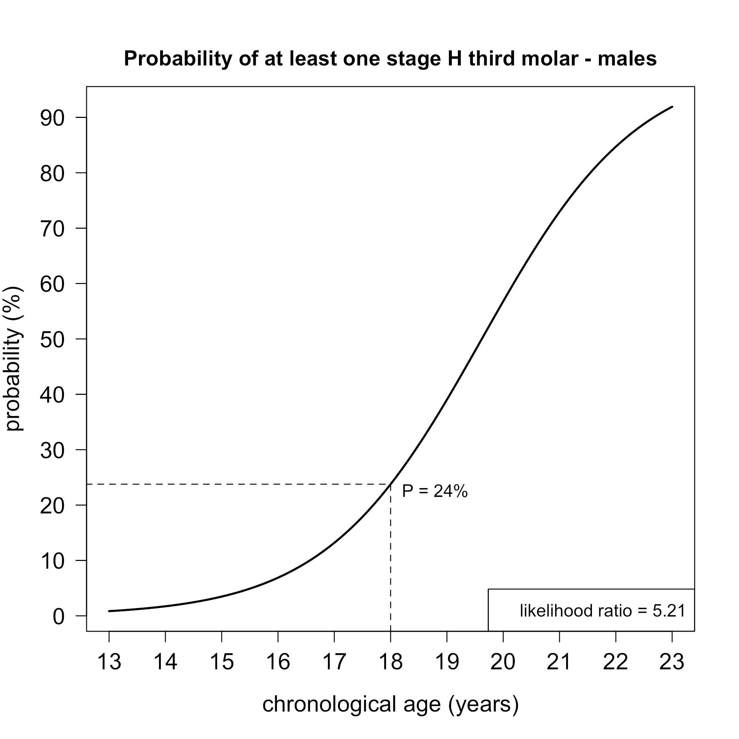
These results are unpublished. The mean and SD of the age of attainment of one or more stage H third molars was estimated as 19.6 SD 1.3 years using logistic regression, from which the probability of being dentally mature can be computed for different ages, assuming a logistic distribution. At 18 years the probability is 24%, at 17 years it is 13% and at 16 years 7%.
The figure (right) shows the probability of 24% at 18 years. This is clearly smaller than the 61% probability for a mature x-ray, which might suggest that dental age is more informative than bone age for age assessment purposes. But again this probability is not directly relevant, and instead one should rely on the LR to make the judgement. In the presence of a mature third molar, comparing the probabilities of being under 18 and over 18 gives an LR of just 5.2 (see graph), which is only marginally informative. An LR of 10 corresponds to age 15.8 years, which is very similar to that for bone age.
Thus dental age suffers from the same lack of precision as bone age for forensic age assessment. Ages older than 16 cannot convincingly be excluded using either method.

